**REPORT OF EVALUTION**

**AIM:** design a system with two bottom such that a Red light when any bottom is pressed during day b. Green light when both buttom are pressed during day.

**Circuit diagram**:

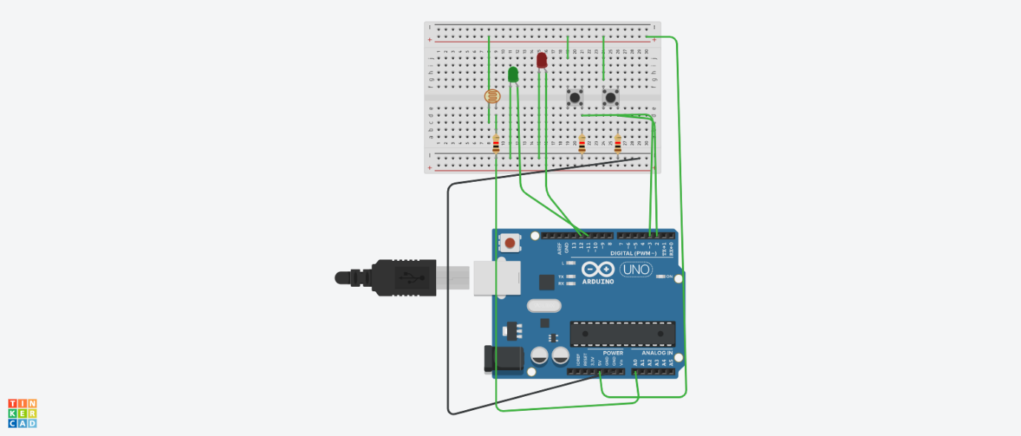

**Theory**

Concept used: LDR is used (to sense the light) and Arduino device is used. Red and green led is used to give output. Switch is used.

**LEARING & OBSERVATION:** when its day time and one of the switches is pressed than red light is glow. When a both of the switch is pressed than green light is glow.

We learn the how to make circuit on the breadboard by using tinker card. We also learn the working of LDR with switch.

Learning outcome: when a switch is pressed than red led glow and when both switch is pressed than green LED glow.

***PRECAUTIONS:***

***Check the led before doing the connections.***

***If the connection is wrong then circuit will not work.***